**IN THE NAME OF GOD**

FUNDEMENTAL COMPUTER PROGRAMMING

**REPORT**

**DATE : 23 JANURY**

**TEACHER ASSIST : MR ABBASSI**

**WITRERS :**

**ALI ASNAASHARI (9732510)**

**This Project Is About Managing A Bank's Accounts.**

**In This Project We Have Shown 12 Features Of A Banking Site,** **That**

**Includes :**

* **SIGNUP**
* **SHOW ACCOUNT LIST**
* **CREATE ACCOUNT LIST**
* **GET BANK ACCOUNT LOGS**
* **ADD ACCOUNT OWNER**
* **BLOCK ACCOUNTS**
* **CLOSE ACCOUNTS**
* **RETRIVE ACCOUNTS**
* **RETRIVE OWNER**
* **TRANSACTION LIST**
* **LIST GET TRANSACTION**
* **Notice**

**IN THIS PROJECT DJANGO WAS MIDDLE WAY BETWEEN CLIENT AND SERVER.**

**You can see Django's environment in the photos section(****page 4****).**

* **Description**

**Home Page Is Login Page By Entering Your Username And Password You Will Be Logged Into The Main Bank System(****PAGE 5****).**

**In The Main Menu Of Your Site You Can Access Your Coworkers Account By Using The Sign Up(****page 6****).**

**You Can See The List Of People Who Have Created An Account By Clicking The show Account List.(****page 7****).**

**In The Next Section You Can Create An Account With Your Information(****Page 8****).**

**In The Bank Account Log Section You Can See Your Account Logs By Entering The Account Number(****Page 9****).**

**In The Next Part, If The User Requests It Or At The Discretion Of The Bank Or For Any Other Reason You Can Close Or Block The Account By Entering The Account Number (****Page 10).**

**Strange But Real You Can Create A owner Account By Importing A**

**National Code(****Page 11****).**

**You Can Do Retrieve Account By Entering An Account Number Or You Can Do It By Entering A Nationalcode(****Page 12****).**

**Do Transaction , How? Just Click On Transaction And Fill Out The Form Coorectlly(****Page13****).**

**And At The Last Step , You Can See All The Transaction By Clicking The List Get Transaction(****Page14****)**

**By The Way, You Can Go Back By Clicking On The Previous Button.**

**IMAGES**

**Django's environment**

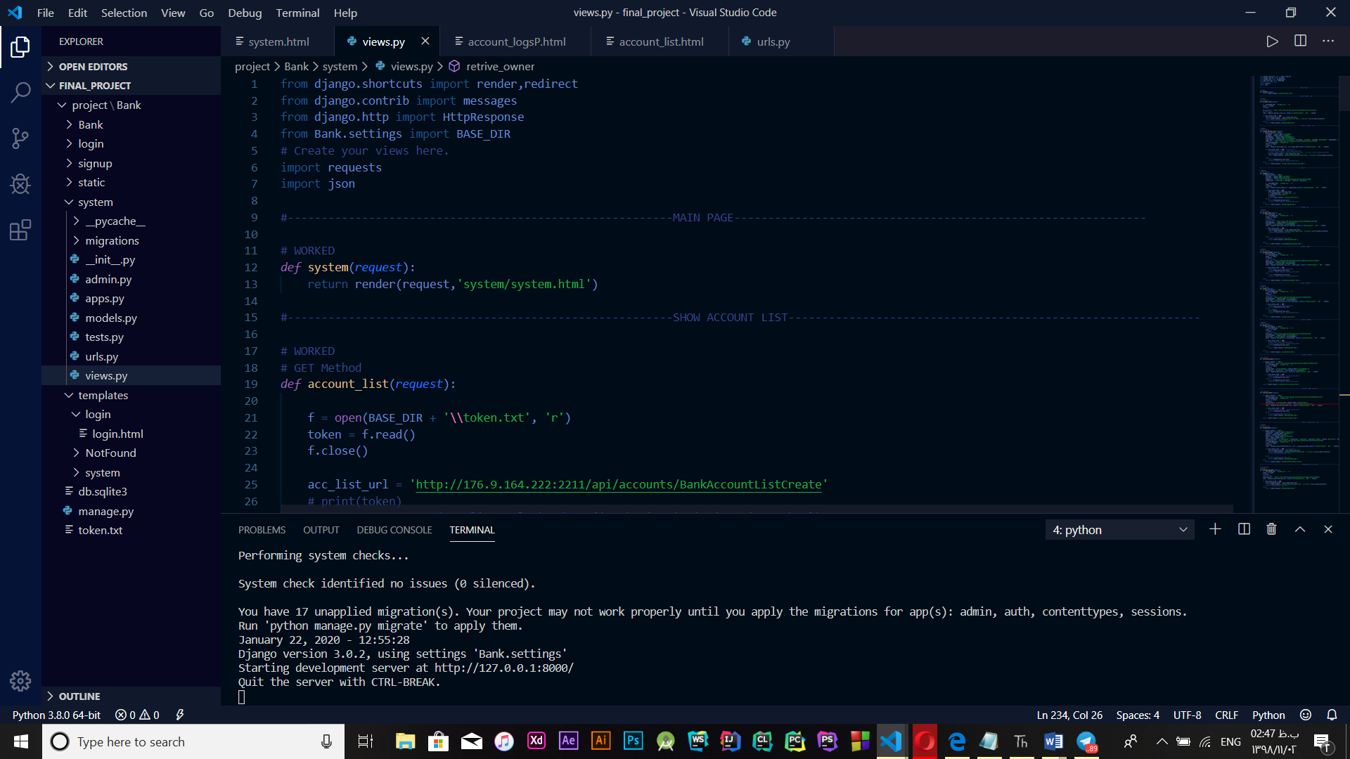

**Login page**

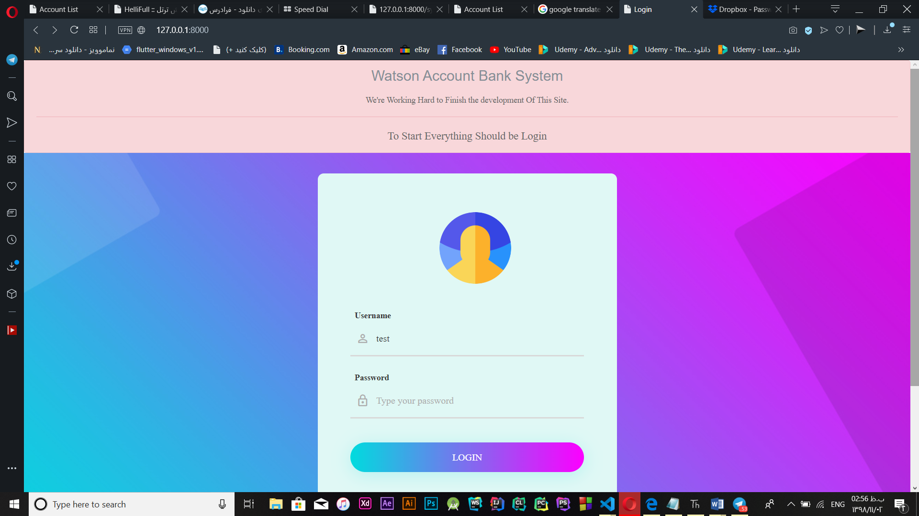

**Signup page**

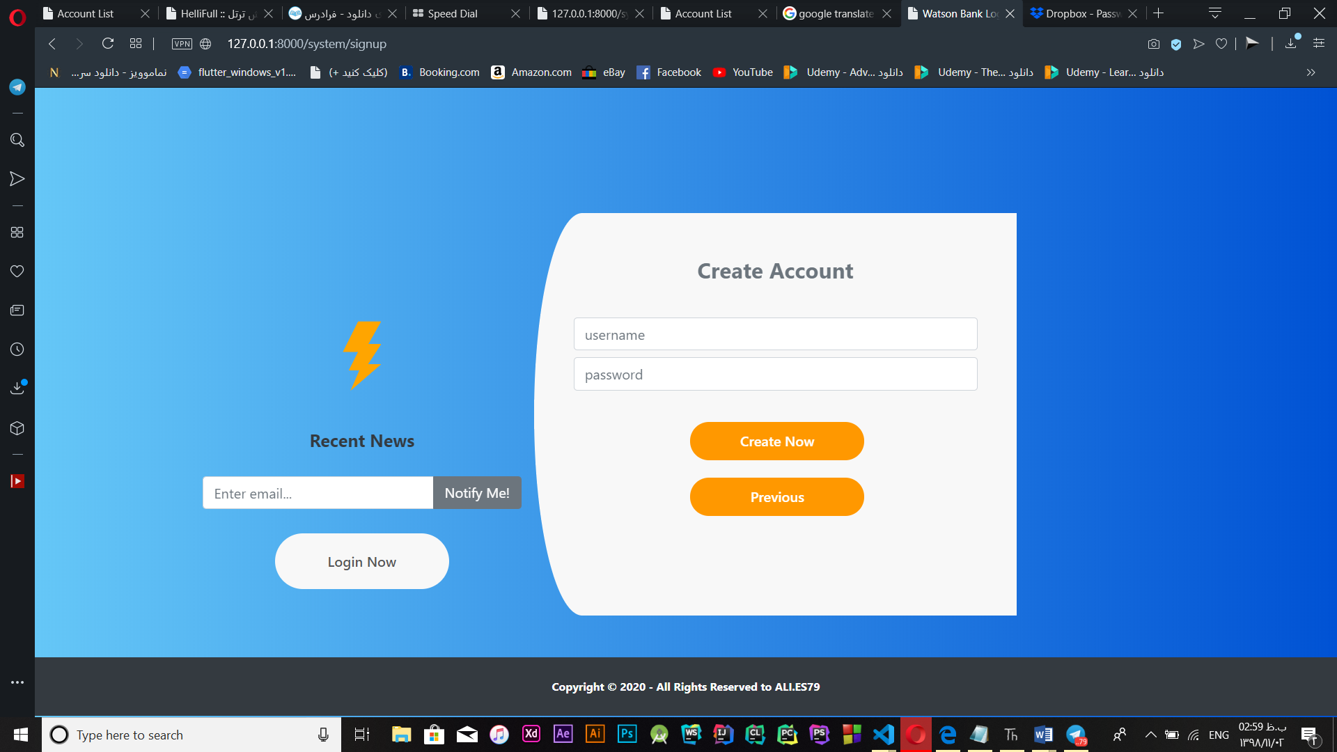

**Show Account List**

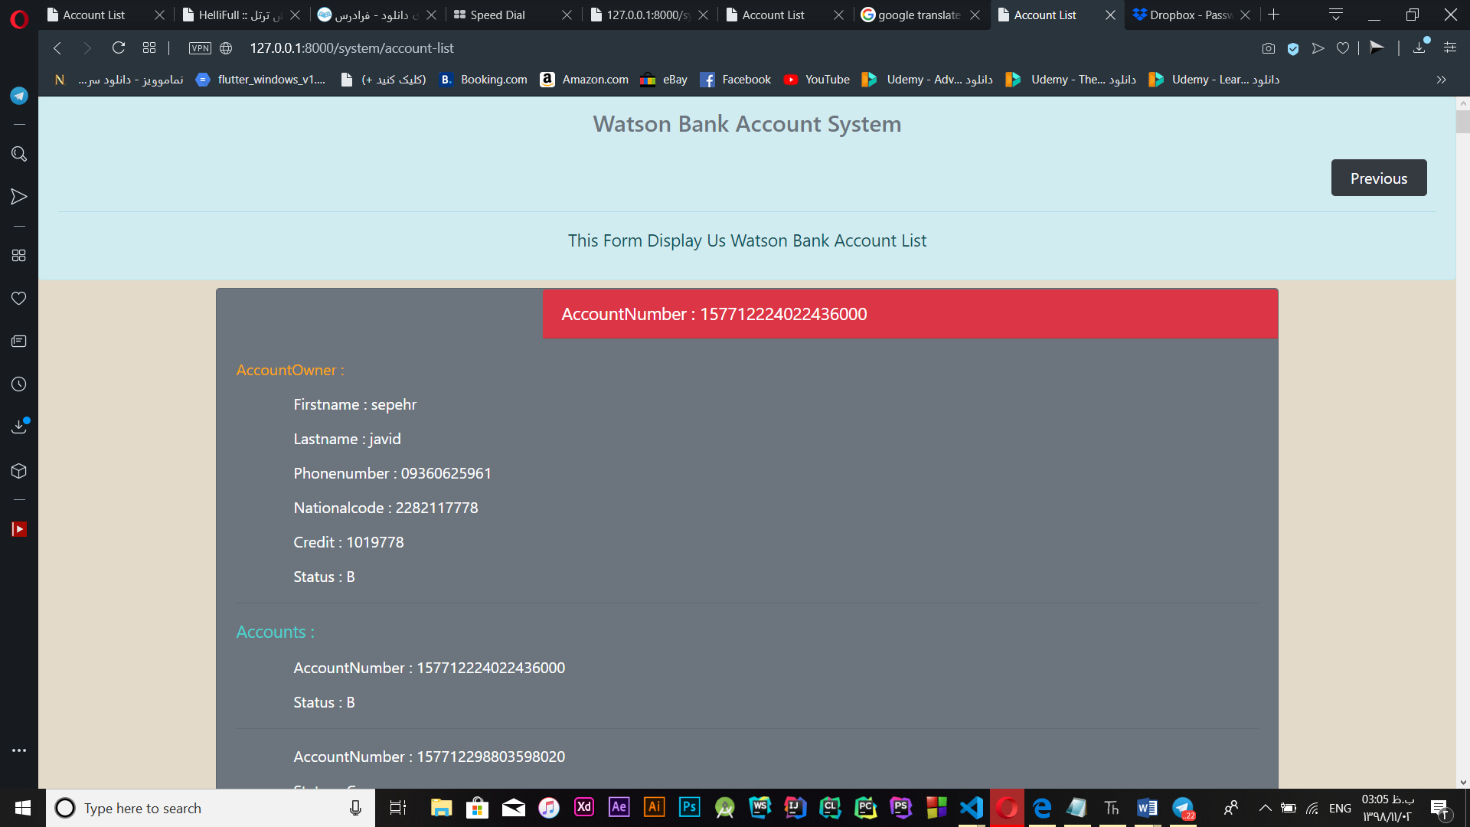

Create account

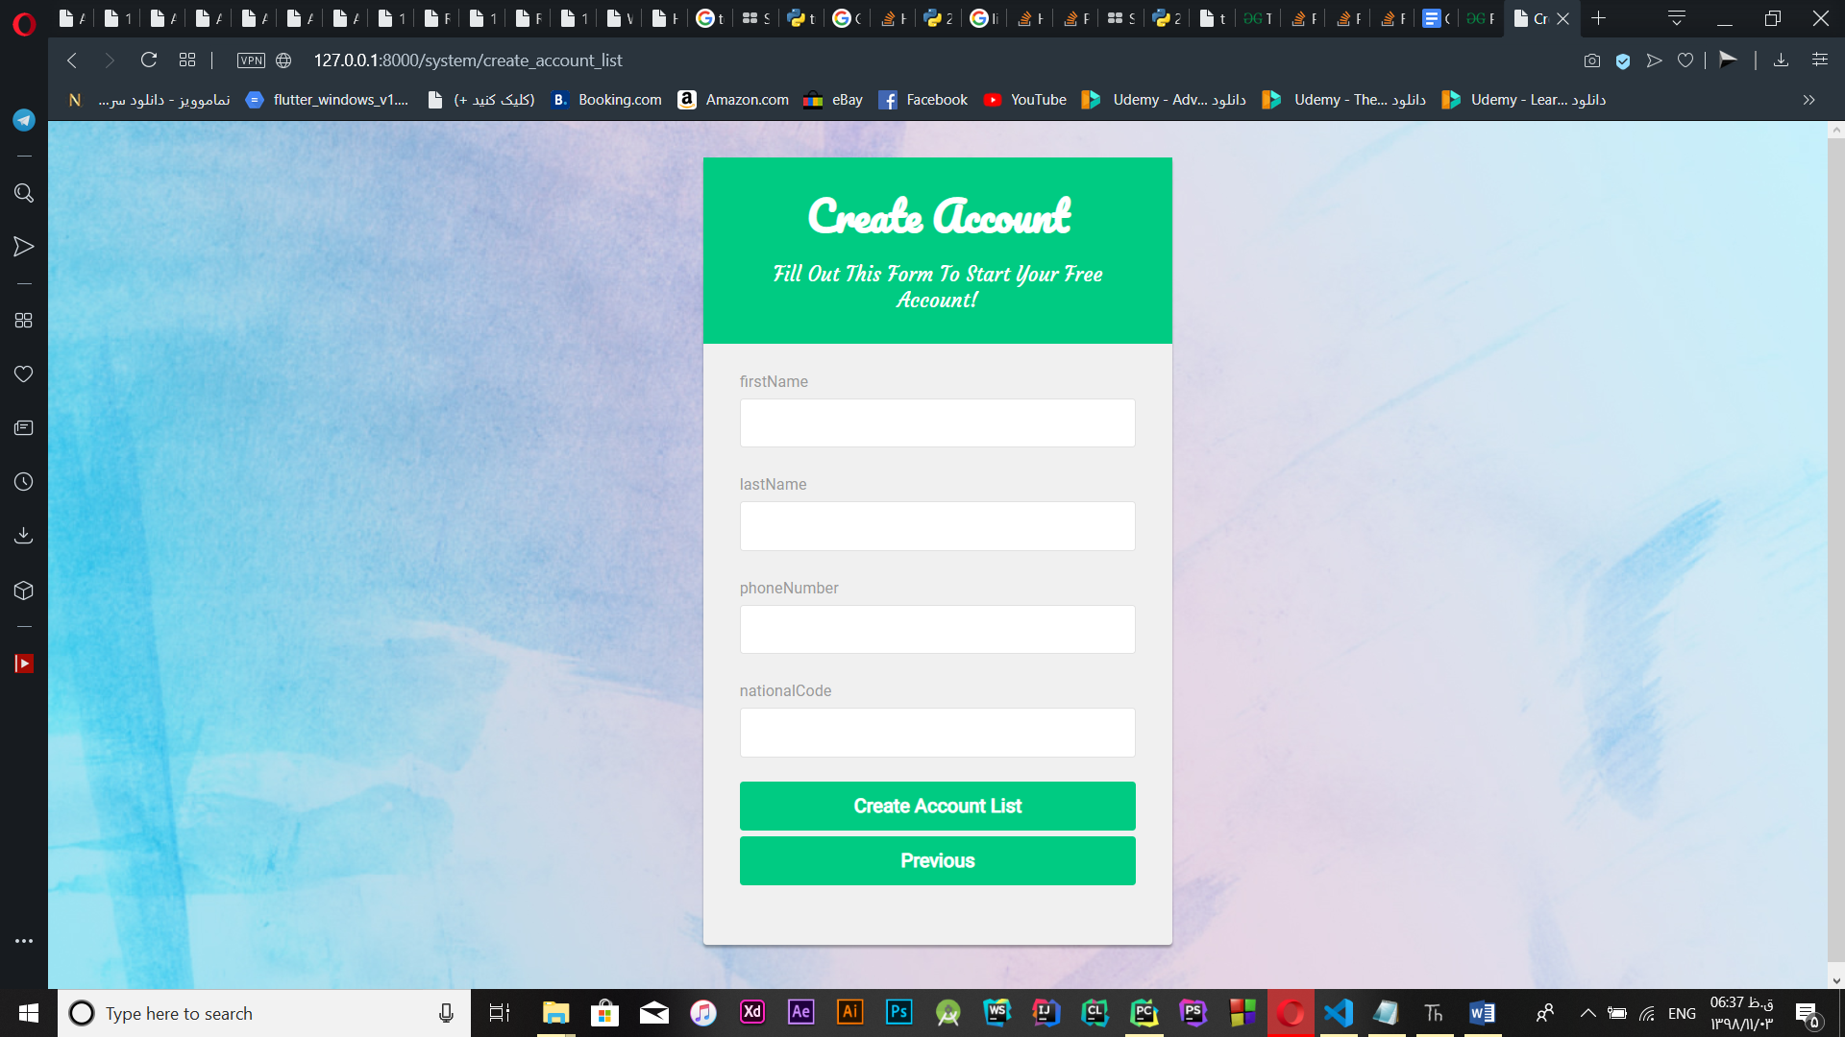

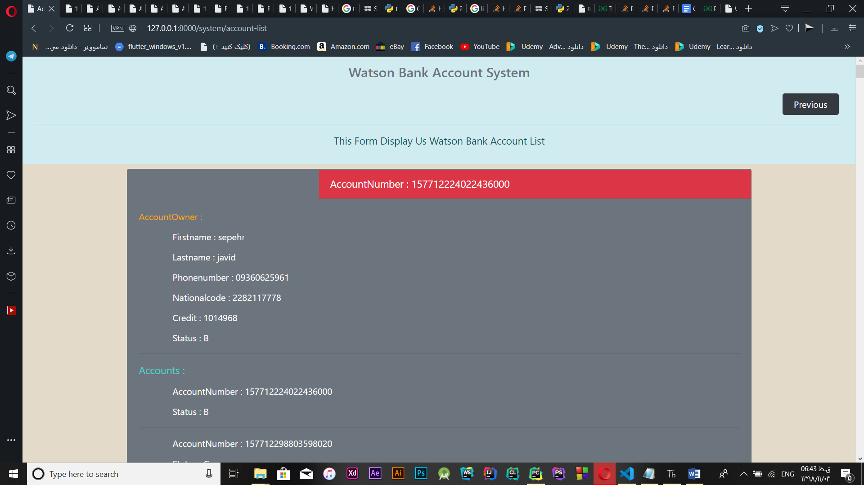

Account Logs

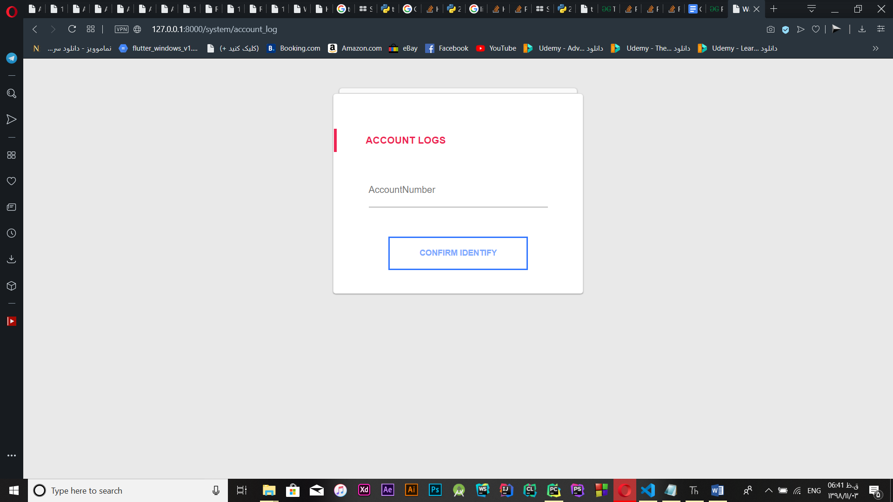

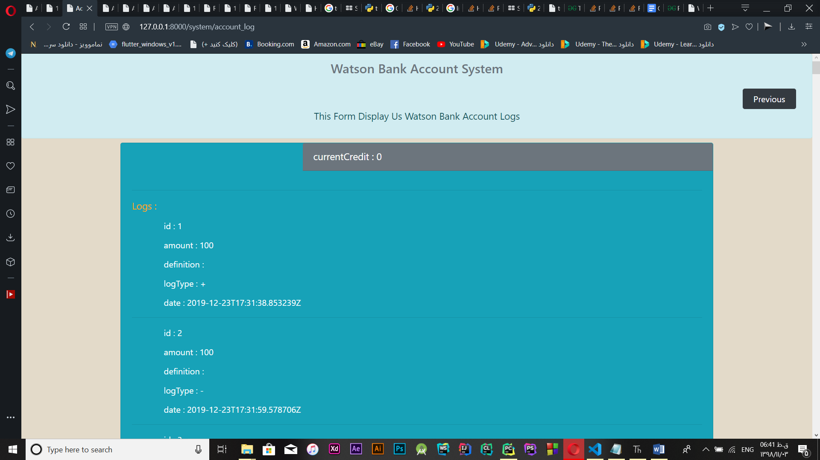

**Block and Close Account**

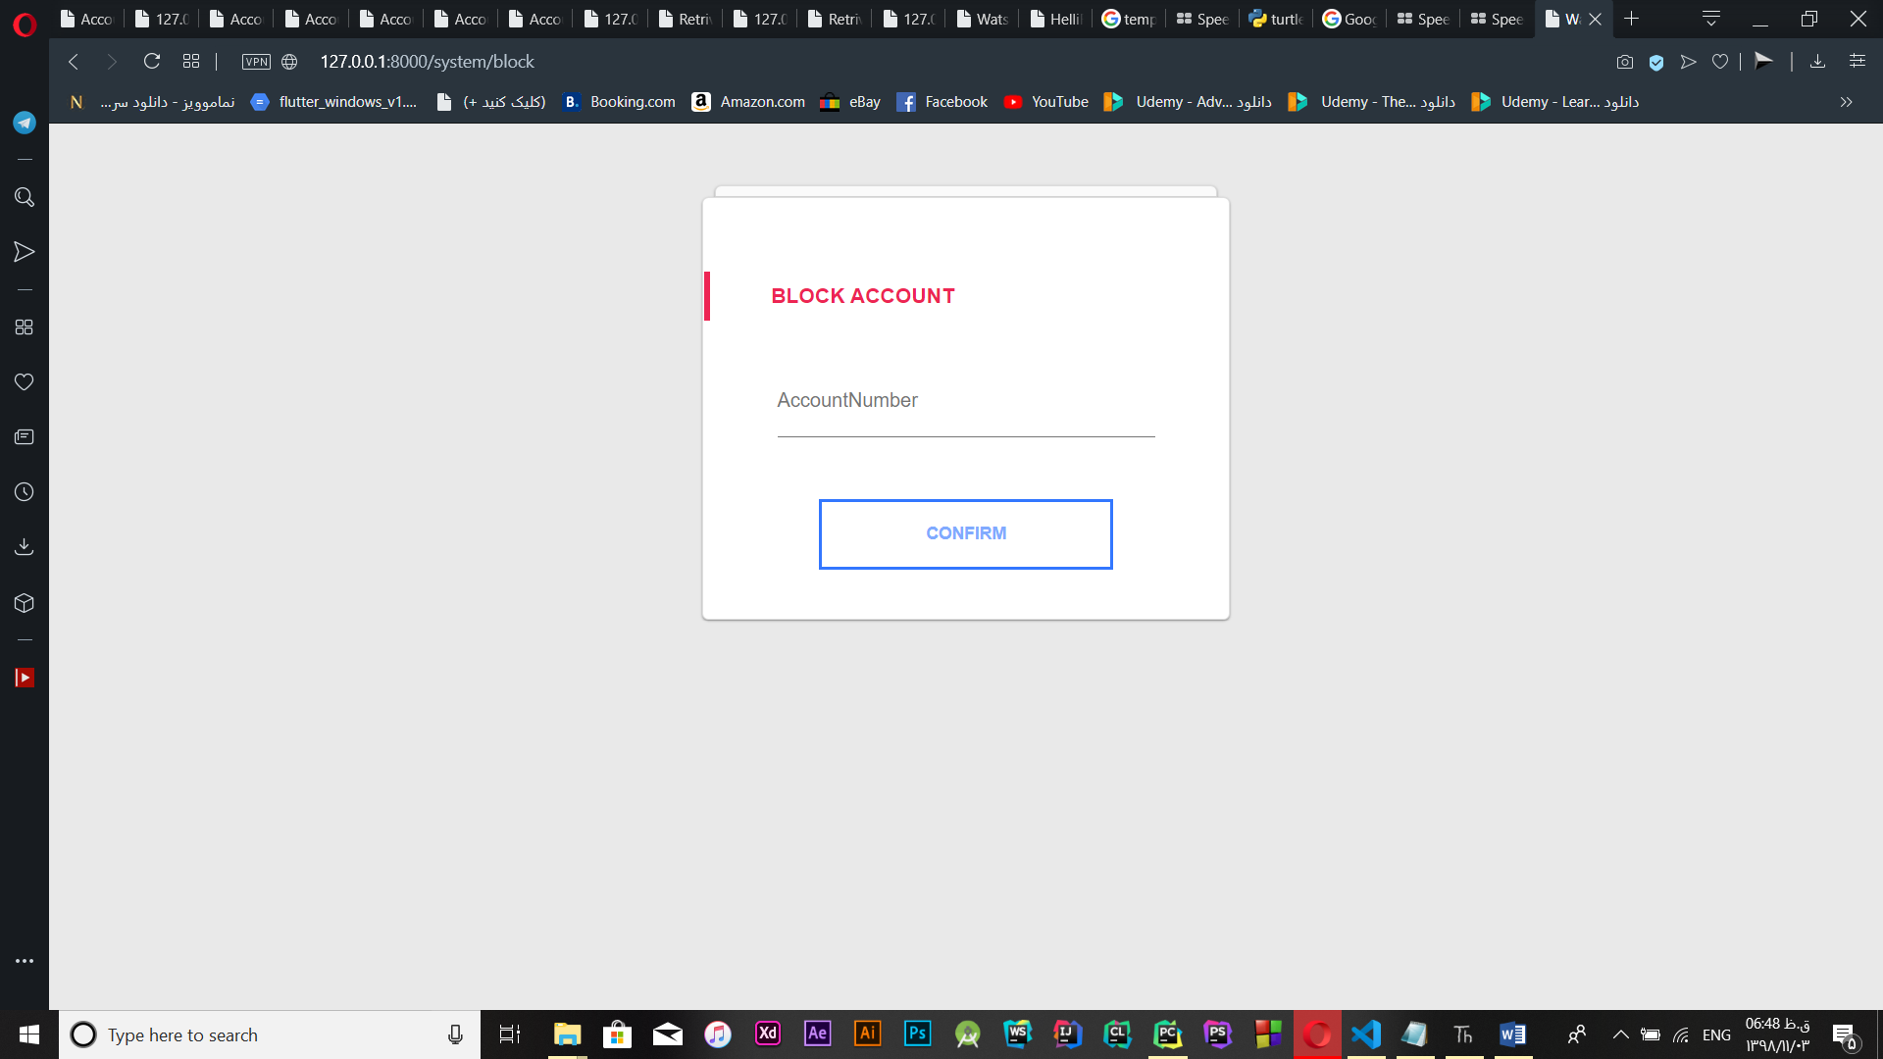

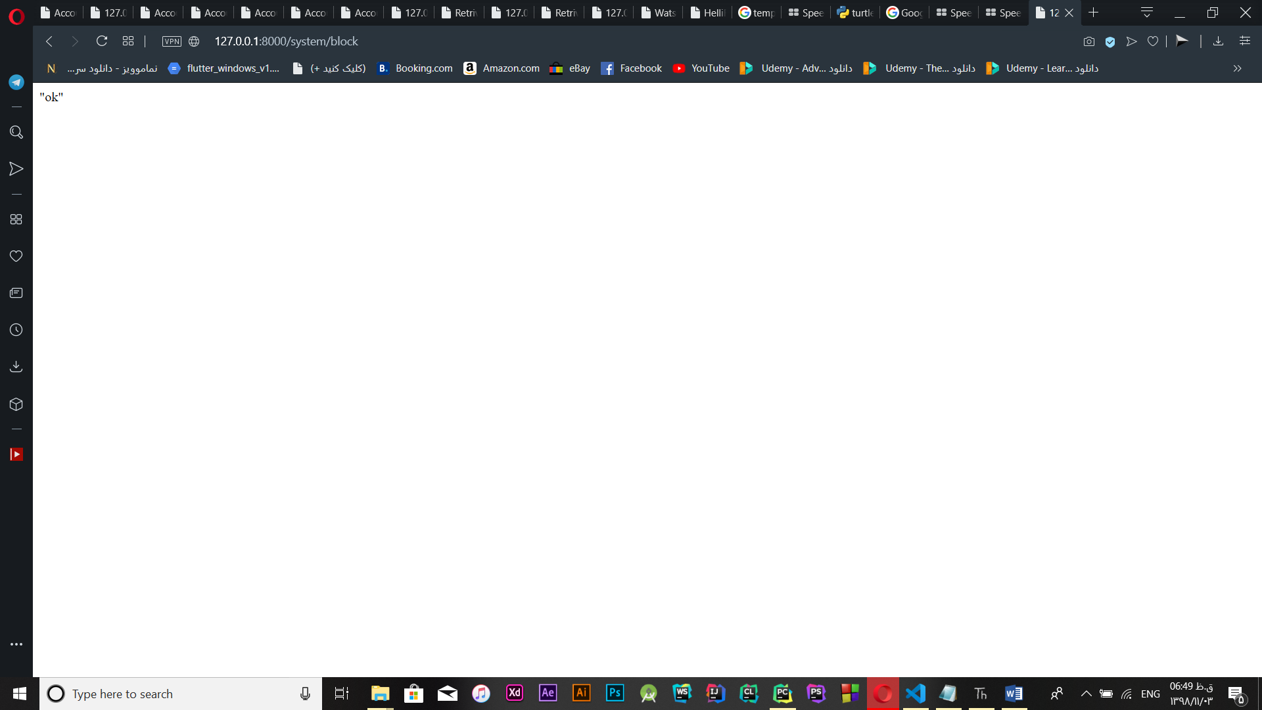

**Account Owner**

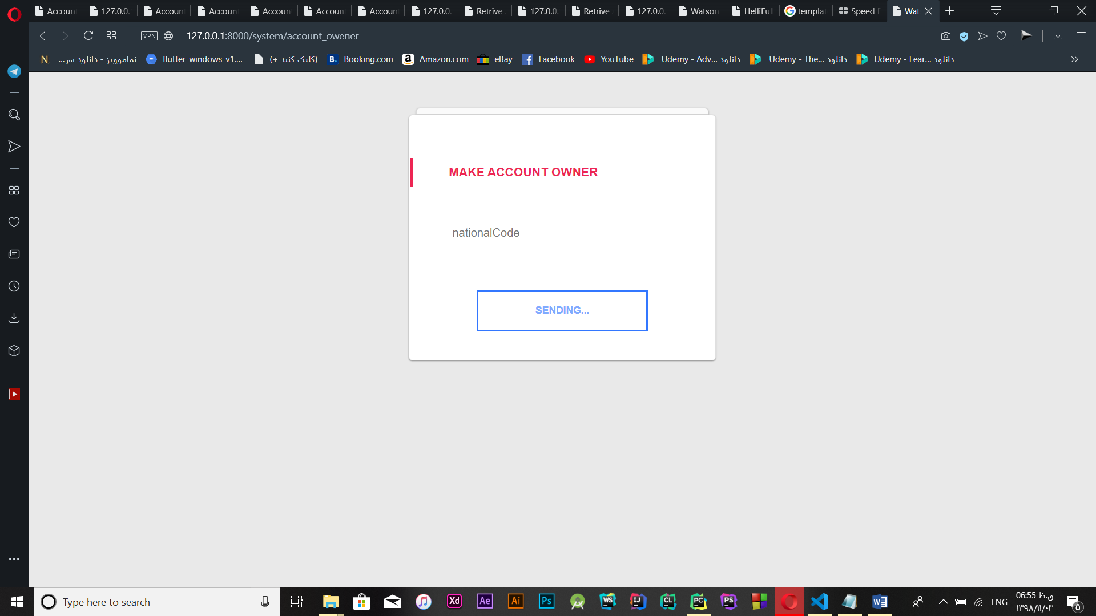

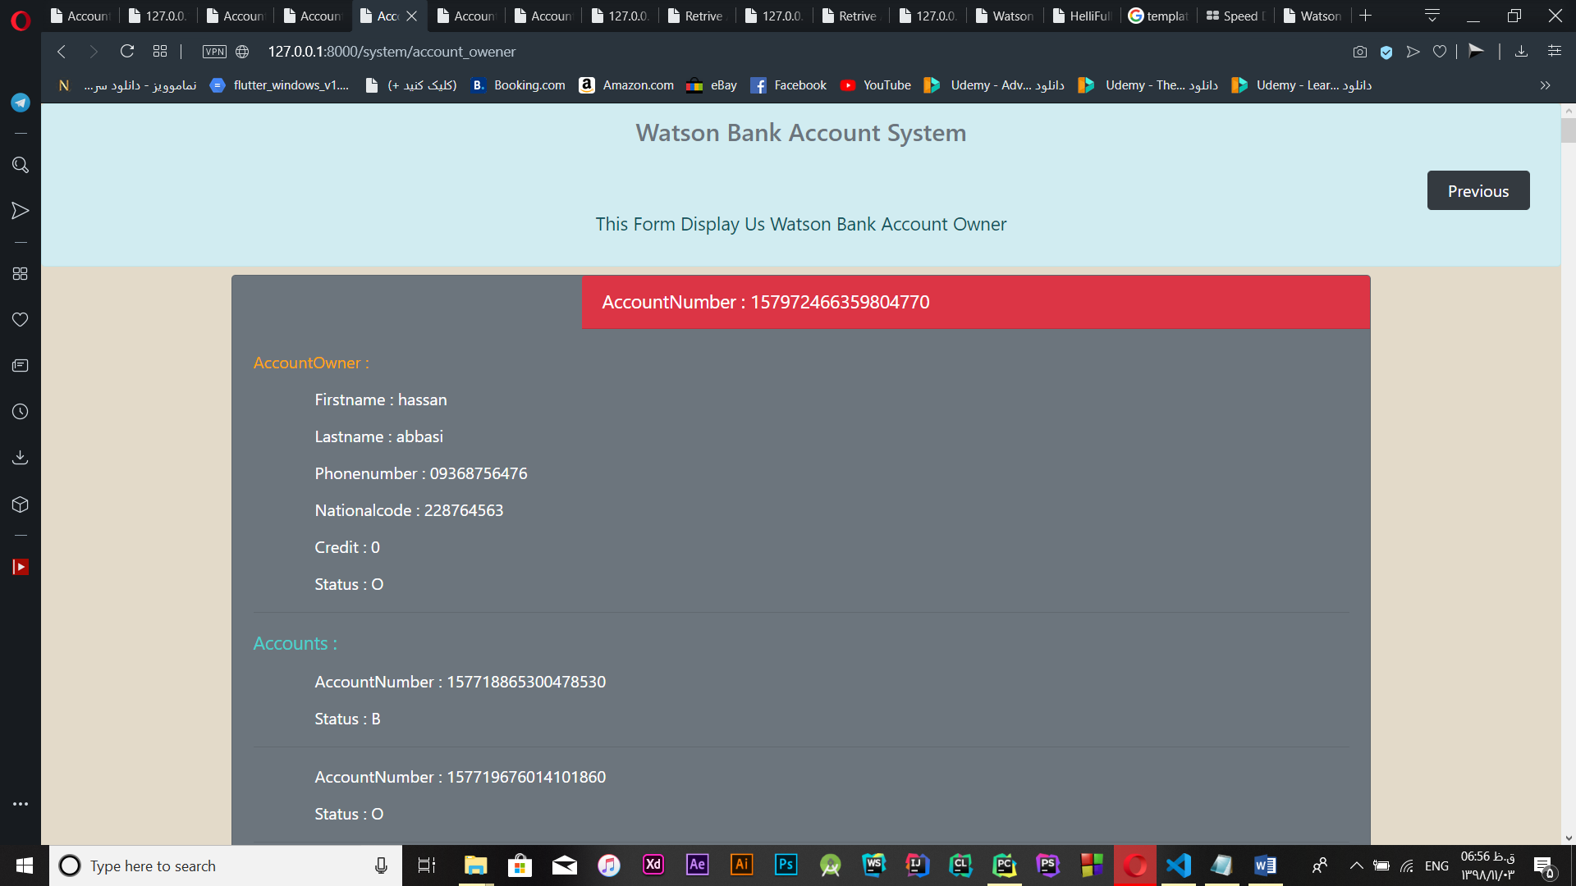

**Retrieve Account**

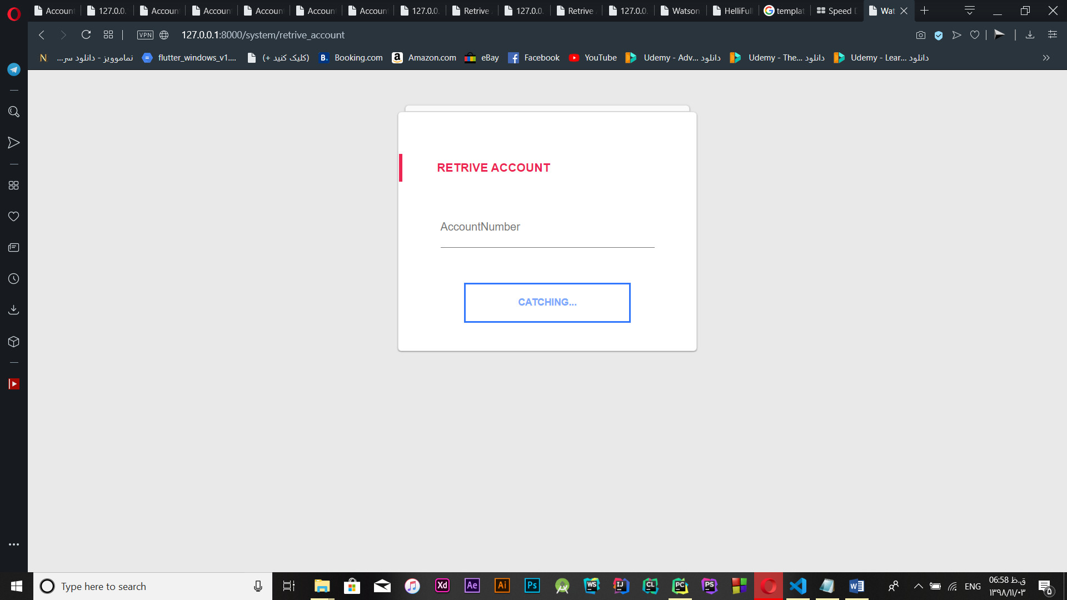

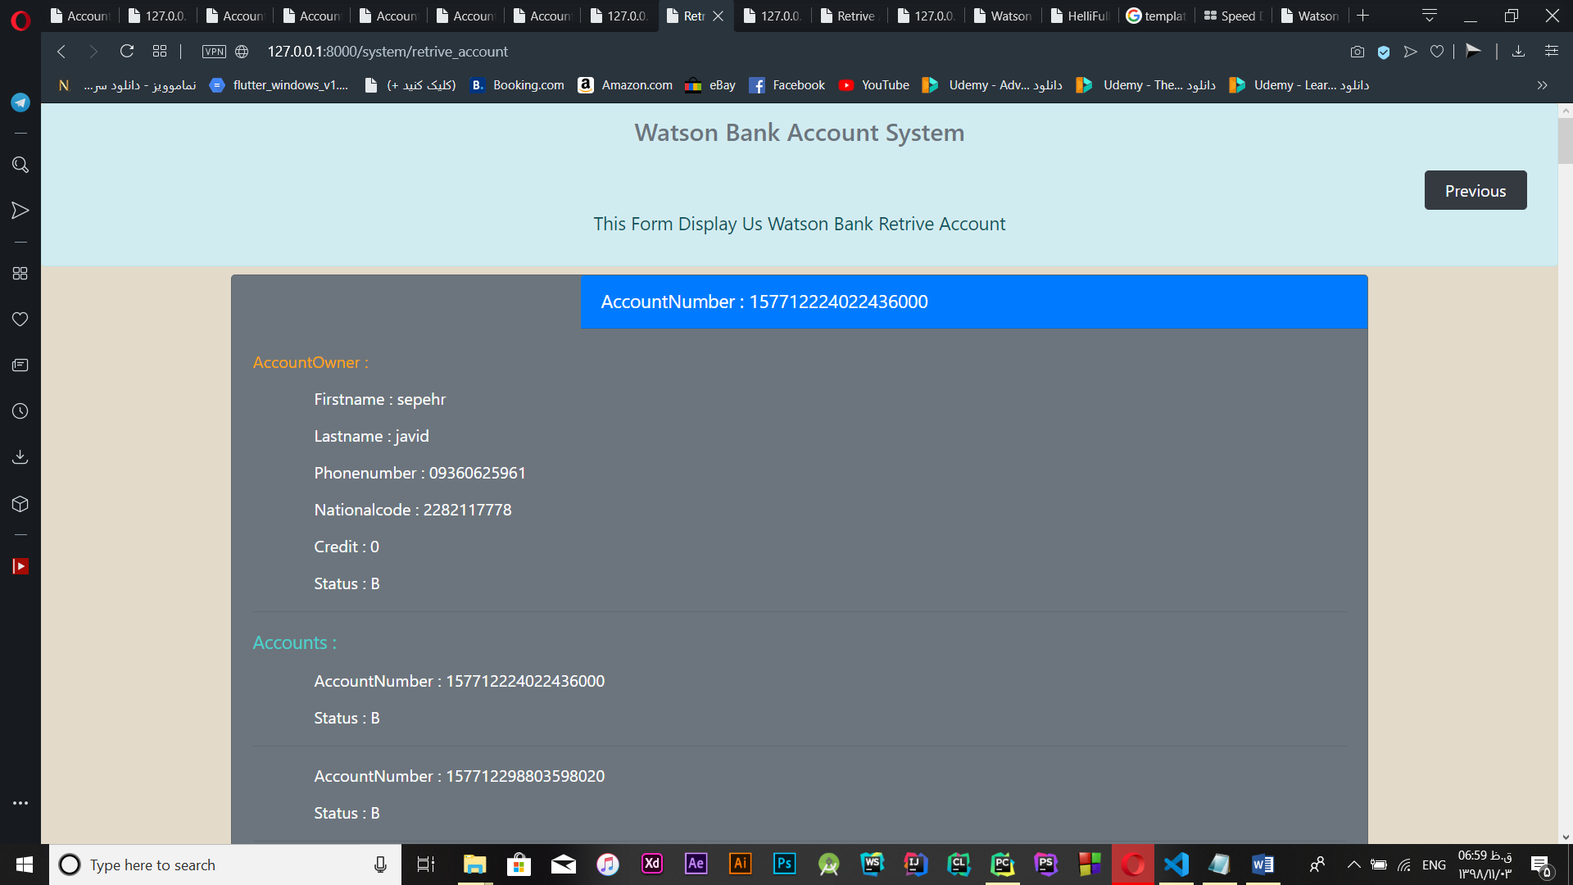

**Transaction**

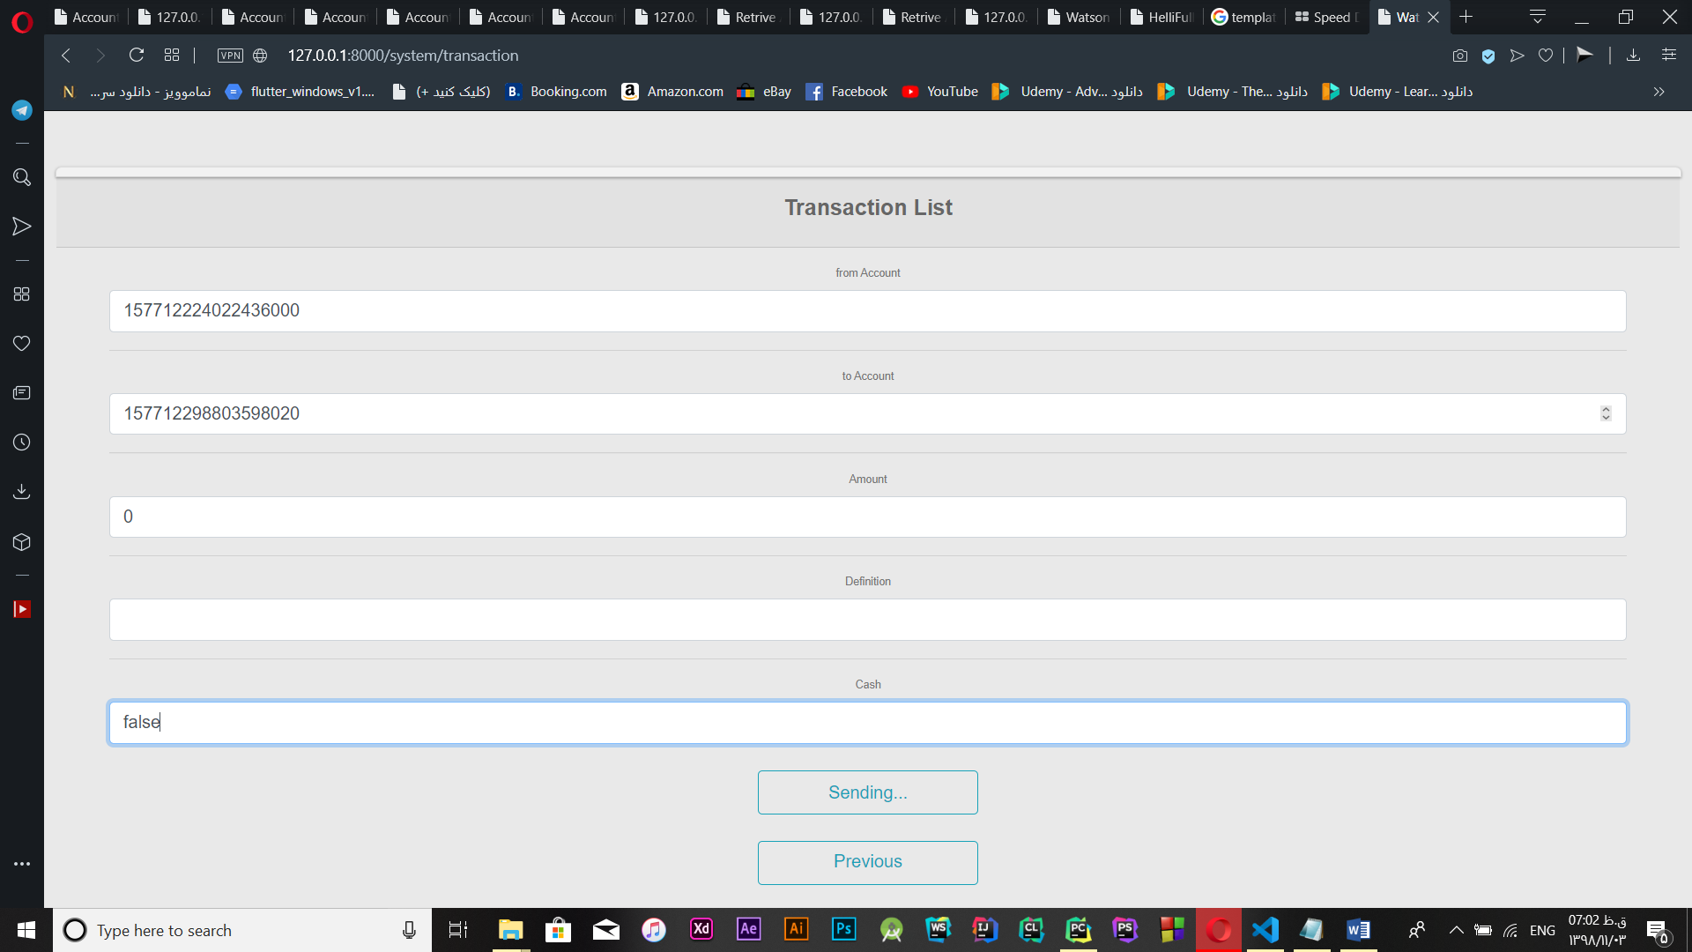

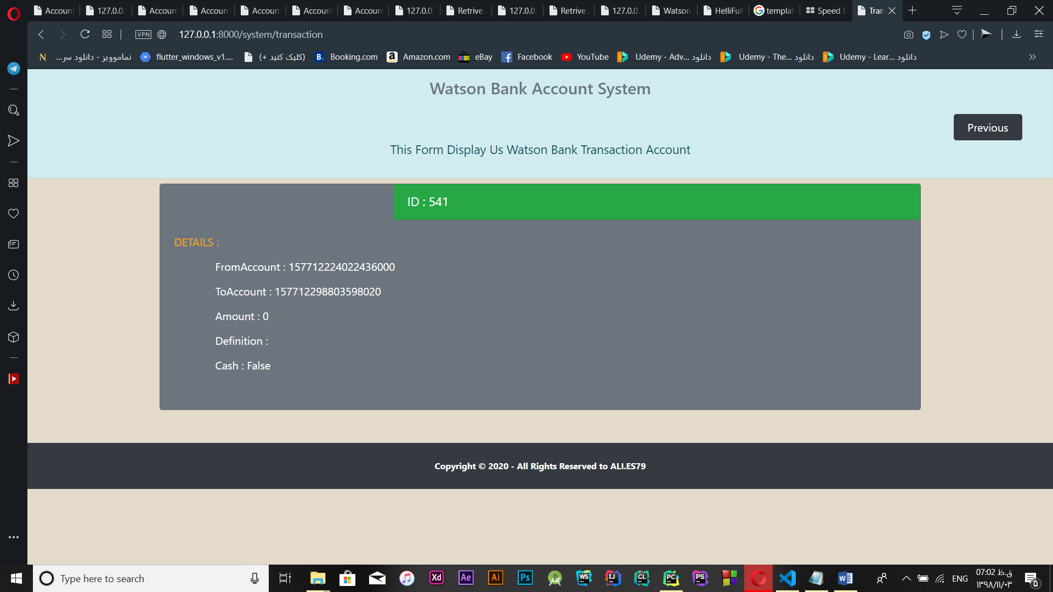

**All The Transaction**

